HURBANCHAL UNIVERSITY
Hello
hi
DEPARTMENT OF COMPUTER ENGINEERING
KHWOPA ENGINEERING COLLEGE
LIBALI-08, BHAKTAPUR

A MID-TERM REPORT
ON
Literature Efficient Architecture Folio (LEAF)
Project work submitted in partial fulfillment of requirements for the award of the degree of Bachelor of Engineering in Computer Engineering (Third Semester)

SUBMITTED BY
Jayadev Tripathi (780314)
Sahana Shrestha (78036)
Sanjib Kasti (780339)
Upendra Shahi (780347)

UNDER THE SUPERVISION OF
Er. Avijit Karn

06 September 2023

ACKNOWLEDGEMENT
We would like to express our heartily thanks to our Purbanchal University for including Project I as part of the curriculum and thank our project supervisor Er. Avjit Karn who has supervised and motivated us to fulfill this project before the timeline.
We also extend our deepest gratitude to our Khwopa Engineering College and Department of Computer Engineering (HOD. Er. Bikash Chawal and all the faculty members) for providing us with a wonderful environment, excellent guidance, and supervision.

With Regards,
Jayadev Tripathi
Sahana Shrestha
Sanjib Kasti
Upendra Shahi

ABSTRACT

Our project LEAF (Literature Efficient Architecture Folio) is an architecture for the manipulation of literature-based contents and creations. It is an efficient platform for all literature enthusiasts. The system is based on the localized server (i.e. data are stored only in the local system or user’s system). Supporting multiple users to engage in a system and have their interaction, the system provides secured sessions. Also providing limiting functionality to the guest users, it is totally concerned with promoting enthusiasm in literature and helping in organizing users’ creations enabling them to create their project and collaborate by adding the members who can access their own credentials in the same system.

This console-based application will also allow the user to view their analytics and engagements, read the loaded contents, and bookmark the preferred and impressive ones. Tying with the fluent, organized, and user-friendly experience; Project LEAF will be part of taking your literature experience to new heights

Keywords: - Analytics, LEAF, Literature, Articles, LeafHandle
List of Figures

Figure 4.2.1: FlowChart 5
Figure 4.3.1: UML Activity Diagram 6
Figure 5.1.1: Home Page 7
Figure 5.1.2:Login Selection 7
Figure 5.1.3: Register Page 8
Figure 5.1.4: Read Section [HOME] 8
Figure 5.1.5: Read Section [Literature] 8
Figure 5.1.6: Read Section [Poem] 9

TABLE OF CONTENTS
INTRODUCTION 1
1.1 BACKGROUND 1
1.2 PROBLEM STATEMENT 1
1.3 OBJECTIVES 1
1.4 FEATURE AND FUNCTIONALITIES OF LEAF APPLICATION 2
1.5 SIGNIFICANCE AND SCOPE 2
CHAPTER 2 3
LITERATURE REVIEW 3
CHAPTER 3 4
PROJECT MANAGEMENT 4
3.1 TEAM MEMBERS 4
3.2 WORK BREAKDOWN PLANNING 4
3.3 FEASIBILITY STUDY 4
CHAPTER 4 5
METHODOLOGY 5
4.1 ALGORITHM 5
4.2 FLOWCHART 6
4.3 UML ACTIVITY DIAGRAM 7
4.4 TOOLS AND PLATFORMS 7
CHAPTER 5 8
PROJECT WORK STATUS 8
5.1 WORK DONE 8
5.2 WORK REMAINING 10
CHAPTER 6 11
REFERENCES 11

CHATPTER 1

INTRODUCTION

BACKGROUND

In today’s digital world, ever field has been randomly digitized. To cope with the efficient digitization in the field of literature LEAF has been developed with prime motive to enrich the user experience with the efficient architecture and user-friendly interface. This project aims to ease users with exciting features and promotes their enthusiasm in literature.
The system allows the user to register into the system and also allows to create the new user. This facilitates the secured sessions which includes logging out user automatically after certain course of inactivity. It remembers the last logged user too. It even allows the user to interact with the system without registering or logging in; but with the limited functionalities. To gain the complete system user registration and logging in is mandatory,
After you login to the system, there is option to choose between general, professional and the management mode. Management mode includes logging you out, changing the user credentials and managing your collaborators. As, every author or literature enthusiasts want their literature identity by their preferred nickname, this system facilitates this too under this section.
Included in the professional mode, you can carry out any specific literature projects by adding collaborators, setting the remainders and tracking your each session's progresses. You can even give the relevant system feedbacks.
Inside into the general mode, you can use the available templates, read and add the contents, keep your general notes, have conversation with the collaborators, bookmark the preferred articles and view the logs and the project description.
Beside these the system provides search functionalities, tags management too.
Once you terminate the program, you are automatically logged out of the system and requires to enter the password again to enter into the system.

PROBLEM STATEMENT

In this digital era, everyone desires to organize their notes in the regular basis. They want to experience their literature experience in a single platform having multiple functionalities and simple and efficient interface. They want to keep records, add teams, have conversation, manage tags, have search functionality and track progress too. And this is mandatory if one wants to move ahead in any respective field.

OBJECTIVES

The main objective of project LEAF is to develop a user friendly and multi-functionality literature repository.

FEATURE AND FUNCTIONALITIES OF LEAF APPLICATION

- User Registration and Login
- Create, Edit, and Delete Literature Entries
- Categorization, Tagging and Bookmarking
- Search Functionality
- Formatting and Styling
- Import and Export
- Random Post Display
- User management
- Security
- Graphical User Interface [GUI]
- Error handling
- Documentation and Help

SIGNIFICANCE AND SCOPE

This project LEAF will be outstanding platform to explore the literature field. This will be useful for one seeking for the tool to enable them to record their creation and gather as a project. This will entirely give outstanding experience of the literature field and helps the individuals to explore their creativity, record it in organized manner, and view the progress track. This also enables to upload ones favorite contents and read it during the leisure.

CHAPTER 2

LITERATURE REVIEW

In this era of advanced technologies, the world is caught up in a single computer or digital device. Every moment and all human activities are associated with the digital platform. Aside, literature is the magic that can overcome sorrows, pain, and loneliness and motivates in every failure and further encourage to achieve the goal. In the digital era, the development of applications provides an amazing platform for organizing and creating literature.
The application like memo in the early keypad phones to the evolved application like: Google Keep, Evernote, Microsoft OneNote, To do List, and soon clarifies the importance of the habit of note takings. On the other side, Evernote, Instapaper, Pocket, Flipboard, Read wise, etc. applications are popular for accessing and reading the literature contents.
“Notes are stored in virtual "notebooks" and can be tagged, annotated, edited, searched, and exported.” Evernote
Neil Gaiman: "Software development is an ally to authors, empowering us to explore innovative narrative structures and collaborate with readers in unprecedented ways. The digital realm offers endless possibilities to enhance and expand the reader's experience."
Salman Rushdie: "Technology has reshaped the literary landscape, enabling us to transcend traditional boundaries. Through software development, we can create multi-dimensional narratives and amplify diverse voices, fostering a truly global literary community."
“You can create, edit, and share notes with Google Keep.”
From the above statements from prominent authors, as a user, every individual wants a well-organized application that not only allows one to create notes and general articles or just provides written articles to look over, but they also want wide range of features that enhance the overall literature experience. Google Keep is concerned only with keeping, editing, and sharing notes while Evernote facilitates reading articles more. However, they lack allowing user to create their typical literature projects, classifying the literature genre, set the nickname, track their analytics, add the collaborator securely, manage tags and search for the prominent literature figures in the same platform. As the one to address these issues and promote the journey through the magical world of literature, the project “LEAF” has been developed.

CHAPTER 3

PROJECT MANAGEMENT

TEAM MEMBERS

The project is carried out by the contribution of the following four team members.
- Jayadev Tripathi [780314]
- Sahana Shrestha [780336]
- Sanjib Kasti [780339]
- Upendra Shahi [780347]

WORK BREAKDOWN PLANNING

The table shows the work breakdown planning of the project duration.
S.N. | Week  Task Description | Duration | 1st Week | 2nd Week | 3rd Week | 4th Week | 5th Week | 6th Week
1 | Problem Identification | 3
2 | Analysis | 5
3 | Design | 9
4 | Coding | 22
5 | Implementing and Testing | 10
6 | Documentation | 27

FEASIBILITY STUDY

It is the aspect that analyze, studies and predict the overall success and potential of the project under several aspects. It is based on extensive research and investigation regarding the project scenario and conceptual models.
- Economic Feasibility: The project does not requires any high financial support as it will be performed in free platform. Further, no any financial needs till its completion.
- Operation Feasibility: This application will run smoothly in minimum hardware specifications and does not needs high requirements.
- Technical Feasibility: A normal literate people who can understand general English Language can easily handle the operation. In case of difficulty, the logs and manuals in the program will clarify it.
- Schedule Feasibility: The expected duration for the completion of this project is around 3 months. The project will be completed in the allotted time frame.

CHAPTER 4

METHODOLOGY

4.1 ALGORITHM

- Start:
- Display introduction: Display a welcome message and introduce the application to the user.
- Ask user to login: Ask the user if they would like to login or sign up for an account or Guest mode.
- If the user chooses to login:
  - Prompt the user to enter their username and password.
  - Verify the user's credentials.
  - If the user's credentials are valid, log them in and display the main menu.
  - If the user's credentials are invalid, display an error message and ask them to try again.
- If the user chooses to sign up:
  - Prompt the user to enter their name, and password.
  - Create a new account for the user.
  - Log the user in and display the main menu.
- If user enters guest mode:
  - Display the main menu.
  - Access to Read module only.
  - If tries to access other, request login/sign up and redirect.
- Display main menu: Display the following list of options to the user:
  - Read literature
  - Collaborate with other users
  - Keep notes
  - Create new content
  - Change settings
- Allow the user to select an option: Allow the user to select one of the options from the main menu.
- Perform the selected action: Based on the option selected by the user, perform the corresponding action. For example, if the user selects "Read literature", display a list of all available literature.
- Repeat steps 7-9 until the user selects "Exit": Continue to display the main menu and allow the user to select an option until they select "Exit".
- Exit: Close the application.

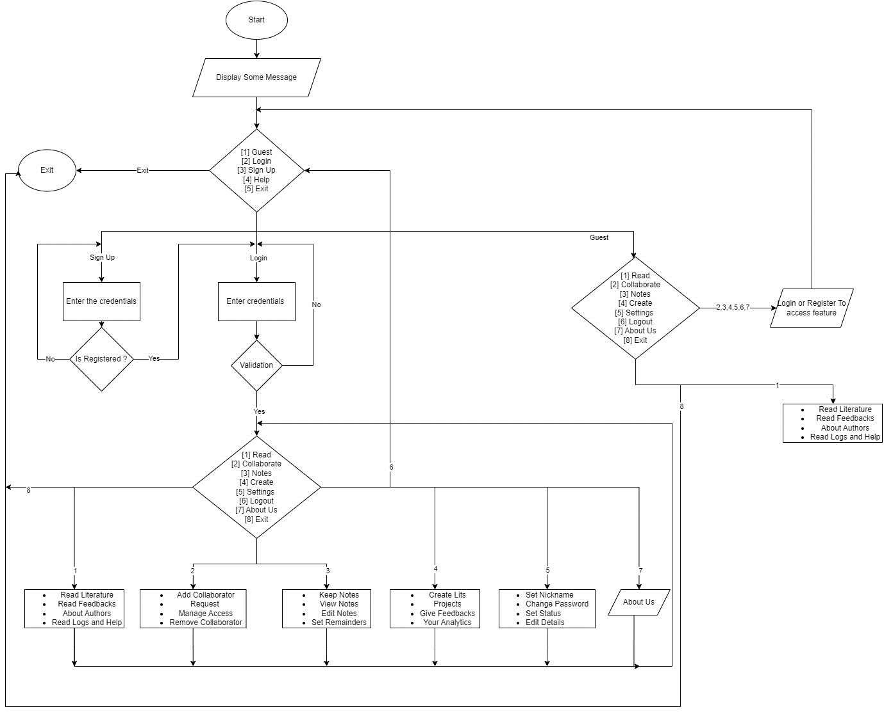
4.2 FLOWCHART

Figure 4.2.1: Flowchart

4.3 UML ACTIVITY DIAGRAM
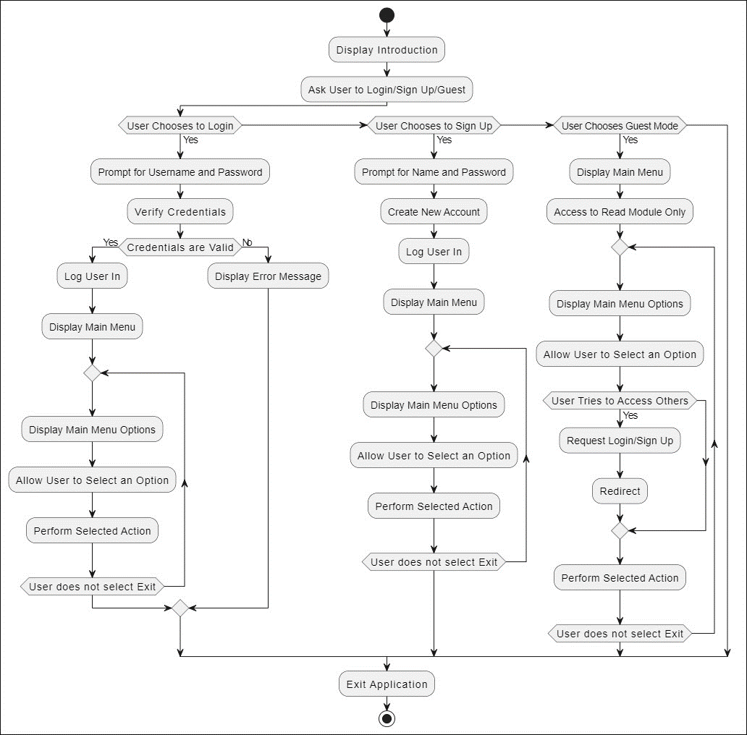
Figure 4.3.1: Activity Diagram

4.4 TOOLS AND PLATFORMS

Tools: Code Blocks
Platform: Windows

CHAPTER 5

PROJECT WORK STATUS

5.1 WORK DONE
In this phase, we have worked on the basic application framework and organized the data flow and arranged the file management. We jointly worked to accomplish the project by dividing it into several modules. In this phase, we have completed:
  - Login Module
  - Read Section Module
  - Home Page Section
  - Basic Graphics Designs
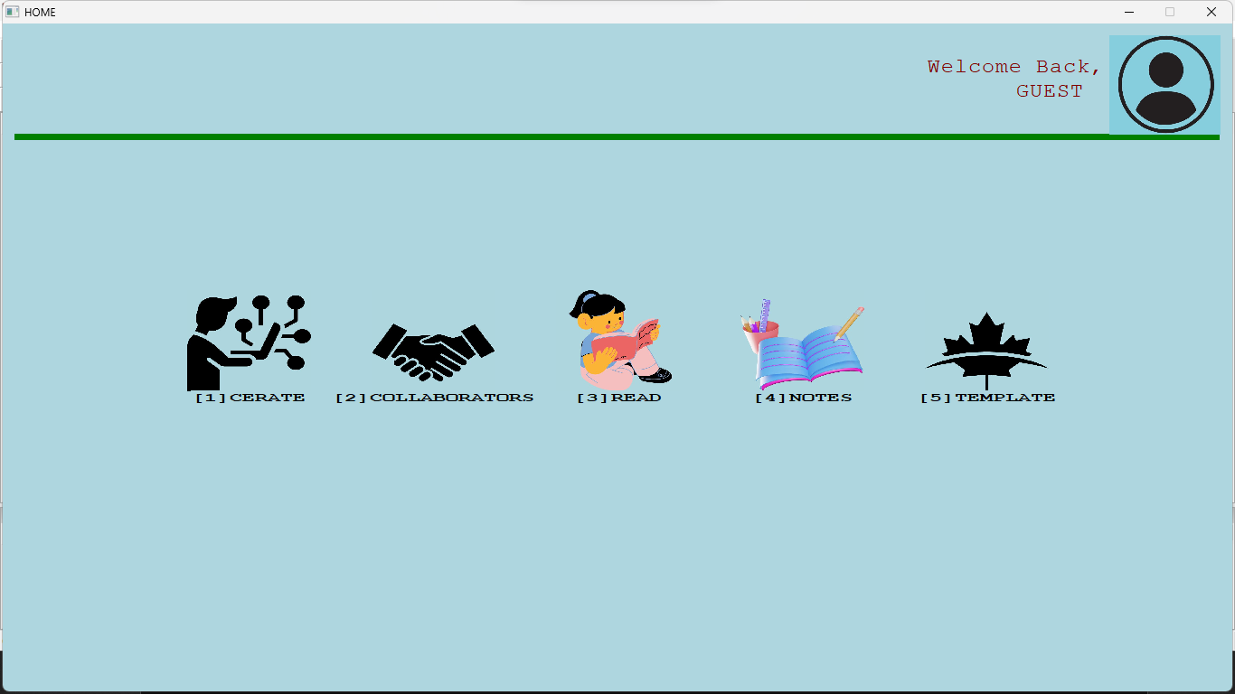
Figure 5.1.1: Home Page
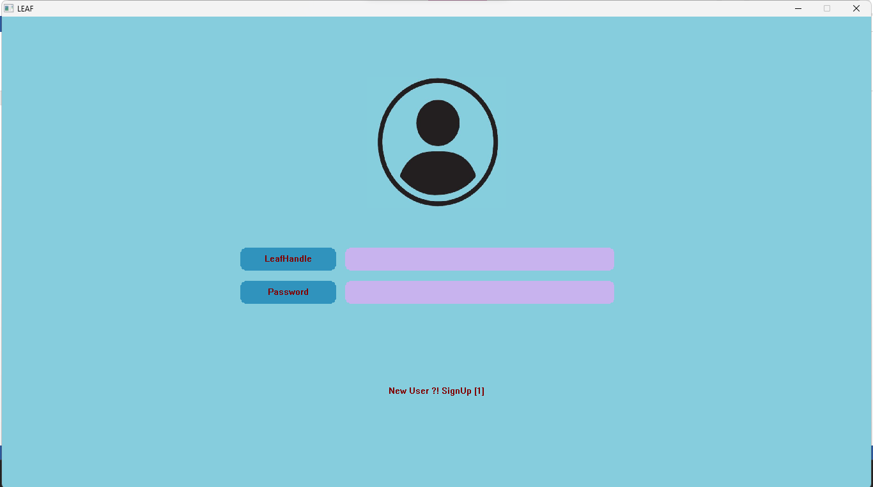
Figure 2.1.2: Login Selection
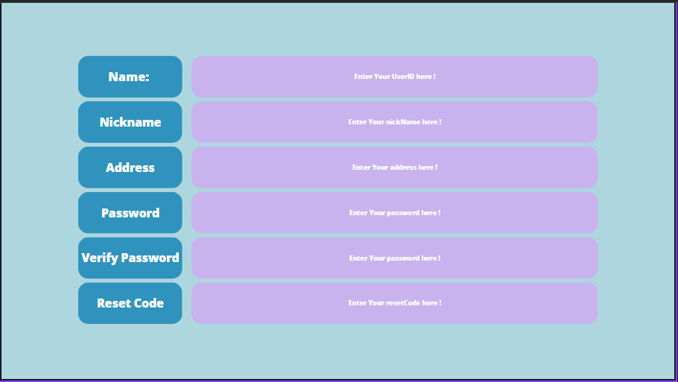
Figure 5.1.3: Register Page (Proposed Design)
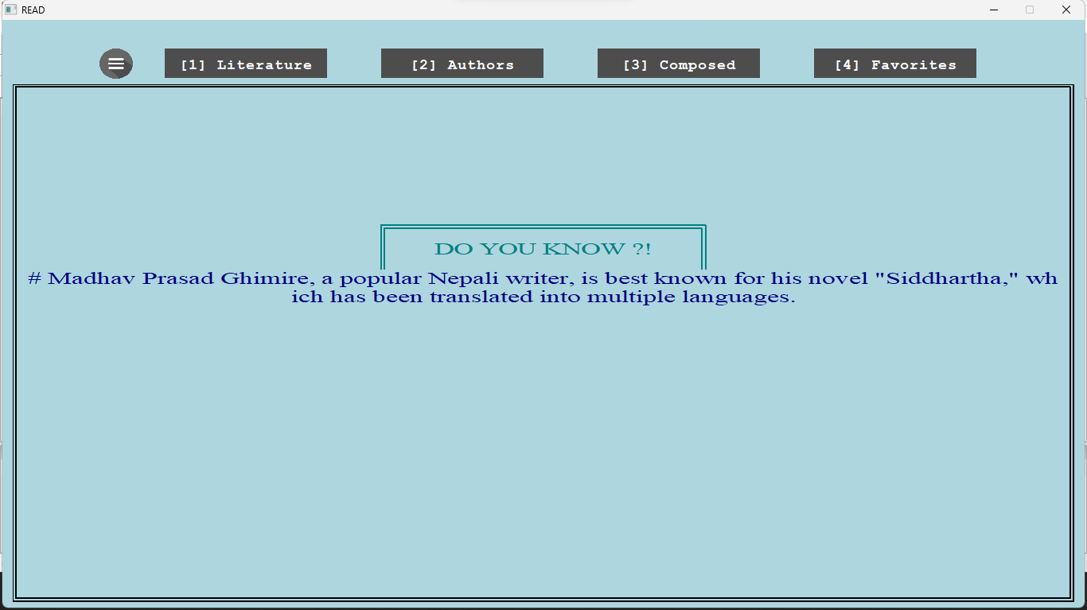
Figure 5.1.4: Read Section [HOME]
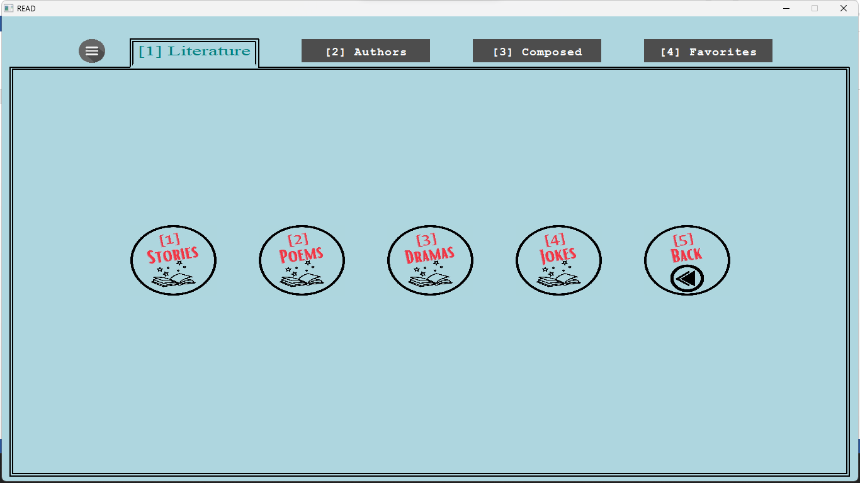
Figure 5.1.5: Read Section//Literature
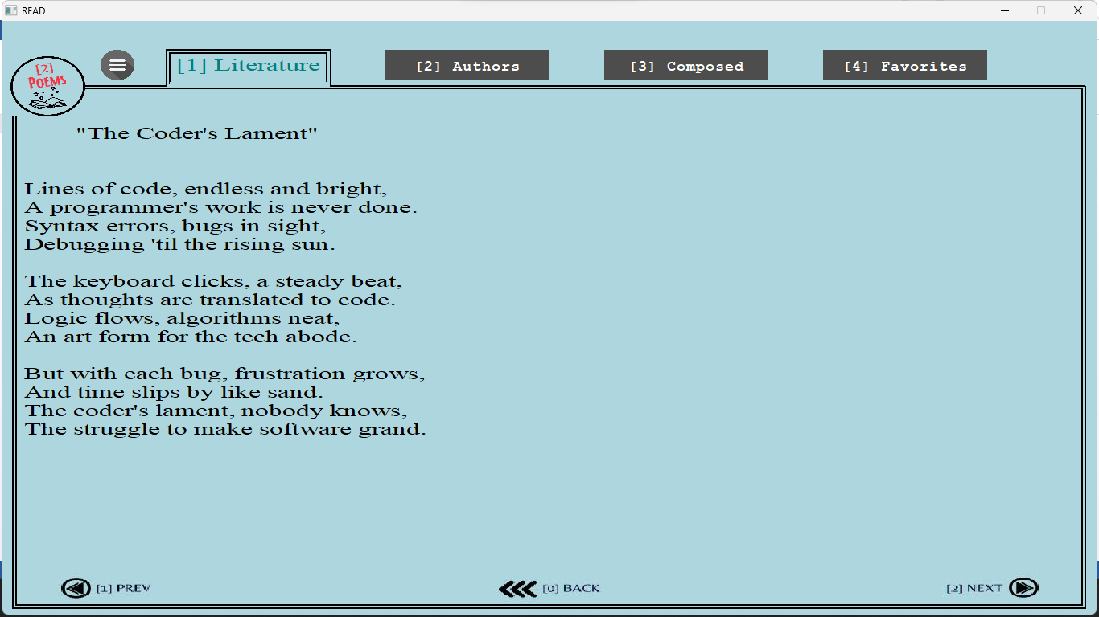
Figure 5.1.6: Read\\Literature\\Poems

5.2 WORK REMAINING
We have completed the basic structure of the application and accomplished the CLI codes in several other modules. Some major tasks that remains includes:
- Sign up module
- Notes Section
- Collaborator Section
- User Management Section

CHAPTER 6

REFERENCES

[1]. en.wikipedia.org/wiki/Evernote
[2].support.google.com/keep/answer/2888240?hl=en&co=GENIE.Platform%3DAndroid
[3] https://github.com/kostasthanos/Social-Network-in-Cpp

